**AP Biology Biochemistry Test**

*Please place all answers to multiple choice questions directly on the zip grade ­bubble form.*

1. The functionality of a protein is determined by its shape when it is in its native conformation. The native conformation of a protein is determined by the set of amino acids that compose the protein’s sequence. A certain protein consists of 325 amino acids. What would be the result if one of the amino acids in this protein were changed?
2. The primary structure of the protein might not be altered but its tertiary structure

and function could be altered.

1. The tertiary structure would be changed but the protein’s function might not be affected.
2. The primary structure, tertiary structure and the biological function could all be altered.
3. There would be no change to the structure or the function of the protein.

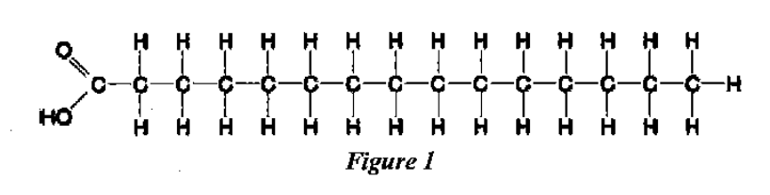

1. Which of the following is true of the molecule shown in Figure 1 above?
2. It is an unsaturated fatty acid.
3. A diet-rich in this molecule may prevent atherosclerosis (hardening and clogging of the arteries)
4. Molecules of this type will pack more tightly in cell membranes, causing the membrane to be more solid
5. Molecules of this type are usually liquid at room temperature.
6. The R group or side chain of the amino acid serine is -CH2-OH. The R group or side chain of the amino acid leucine is -CH2-CH(CH3)2 . Where would you expect to find these amino acids in a globular protein in aqueous solution? (Hint: use functional groups to help you.)
7. Both serine and leucine would be in the interior of the protein.
8. Both serine and leucine would be on the exterior of the protein.
9. Leucine would be on the interior, and serine would be on the exterior of the protein.
10. Serine would be on the interior, and leucine would be on the exterior of the protein.
11. Which of the following correctly illustrates a dipeptide and an amino acid in the optimal position to form a tripeptide?

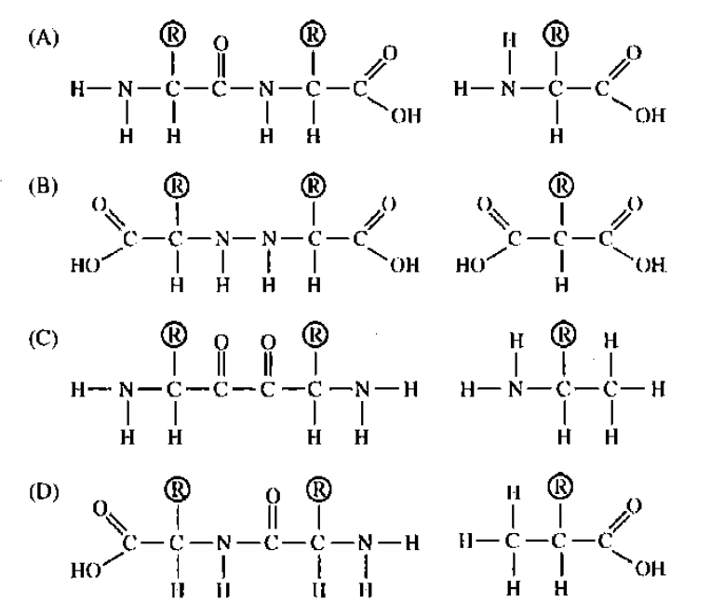

1. Consider the metabolic pathway shown below.

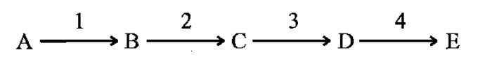

If there is end-product inhibition, which product (B to E) would inhibit which enzyme (1 to 4)?

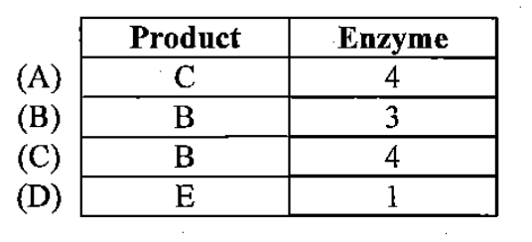

1. The diagram below shows a channel protein in a membrane. Which parts of the surface of the protein would be composed of nonpolar amino acids based on what you know about membrane properties?

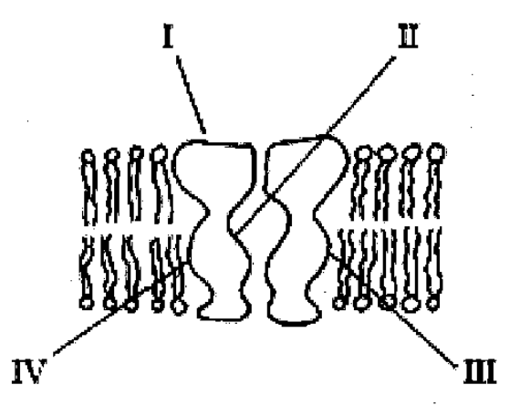

1. I and II only
2. II and III only
3. III and IV only
4. I and IV only
5. Succinate dehydrogenase catalyzes the conversion of succinate to fumarate. The reaction is inhibited by malonic acid, which resembles succinate but cannot be acted upon by succinate dehydrogenase. Increasing the ratio of succinate to malonic acid reduces the inhibitory effect of malonic acid. Which of the following statements are true based on this information.

I) Succinate is the enzyme, and fumarate is the substrate.

II) Succinate dehydrogenase is the enzyme, and malonic acid is the substrate.

III) Succinate is the substrate, and fumarate is the product.

IV) Succinate Dehydrogenase is the enzyme, and malonic acid is a noncompetitive inhibitor.

V) Malonic acid is the product, and fumarate is a competitive inhibitor.

VI) Succinate dehydrogenase is the enzyme, malonic acid is a competitive inhibitor

Based on this information, which of the following statements I- VI above are correct?

1. I, II
2. II, V
3. III, VI
4. III, IV
5. I, IV
6. Humans can digest starch but not cellulose because
7. the monomer of starch is glucose, while the monomer of cellulose is galactose.
8. humans have enzymes that can hydrolyze the β glycosidic linkages of starch but not the α glycosidic linkages of cellulose.
9. humans have enzymes that can hydrolyze the α glycosidic linkages of starch but not the β glycosidic linkages of cellulose.
10. humans harbor starch-digesting bacteria in the digestive tract.
11. the monomer of starch is glucose, while the monomer of cellulose is glucose with a nitrogen-containing group.
12. High levels of cholesterol are considered a major risk factor for heart disease. If cholesterol is so bad for humans, why do cells continue to manufacture it in the first place?
13. Cholesterol is an important energy storage molecule.
14. The presence of cholesterol in the plasma membranes of some animals enables the membrane to stay fluid more easily when cell temperature drops.
15. The presence of cholesterol in the plasma membranes of some animals enables the membrane to decrease fluidity preventing melting when cell temperature increases.
16. Cholesterol is an important component of nucleotides.
17. Cholesterol is used as the base for certain hormones.
18. The presence of cholesterol in the plasma membranes of some animals enables the animal to add hydrogen atoms to unsaturated phospholipids to deal with decreases in temperature

Select which of the following are true reasons for cells manufacturing cholesterol.

1. I, II, III, V
2. II, III, V
3. I, II, V, VI
4. II, V, VI
5. I, II, III, IV, V, VI
6. What do cohesion, surface tension, and adhesion have in common with reference to water?
7. All increase when temperature increases.
8. All are produced by covalent bonding.
9. All are properties related to hydrogen bonding.
10. All have to do with nonpolar covalent bonds.
11. Both A and C are correct.
12. The synthesis of protein or carbohydrate polymers always produces which of the following as a byproduct?
13. ATP
14. Oxygen
15. Carbon dioxide
16. Urea
17. Water
18. Which of the following statements regarding coenzymes is true?
19. They are essential for metabolic reactions in animals but not in plants.
20. They are organic molecules that can facilitate metabolic reactions by behaving like activators for enzymes.
21. They are minerals (inorganic molecules) that alter the pH of cells and thus increase the probability of chemical reactions.
22. They are synthesized in the rough endoplasmic reticulum of eukaryotic cells.
23. They are organic molecules that can reduce metabolic reactions by behaving like inhibitors for enzymes.
24. A feature of organic compounds NOT found in inorganic compounds is the presence of
25. ionizing chemical groups
26. electrons
27. carbon atoms covalently bonded to each other
28. oxygen
29. hydrogen bonds

**Questions 14 – 17**

The questions below (14 - 17) consist of five lettered headings followed by numbered phrases or sentences. For each numbered phrase or sentence select the one heading that is most closely related and fill in the corresponding oval on the answer sheet. Each heading may be used once, more than once or not at all in each group.

Questions 14 - 17 refer to the following graph. The solid curve and the dashed curve represent alternate pathways for the same reaction. One pathway is enzyme catalyzed.

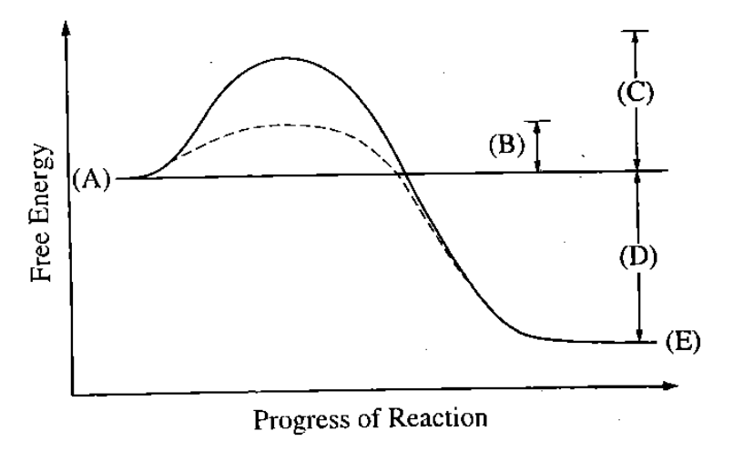

1. Represents the activation energy of the enzyme-catalyzed reaction.
2. Represents the net energy change of the reaction.
3. Represents the energy state of the products of the enzyme-catalyzed pathway.
4. Represents the energy state of the products of the pathway that is not enzyme-catalyzed.

**Questions 18 – 20**

The activity of digestive enzymes was examined in three regions of the digestive system of a crayfish. The stomach, the digestive gland, and the intestine were assayed for enzyme activity at 25oC and pH 7.6. The following results were recorded after repeated measurements.

**Enzyme Activity (μmole substrate hydrolyzed/min/mL extract)**

Enzyme Stomach Digestive Gland Intestine

Amylase 0.01 0.19 0.00

Protease 0.03 11.4 0.01

Lipase 0.02 0.89 0.00

1. From the data presented, which of the following can correctly be concluded about crayfish?
2. Their diet contains no fat.
3. Most digestive enzymes are produced in the stomach.
4. Most digestive enzymes are found in the digestive gland.
5. Amylase is produced in the esophagus.
6. The primary function of the intestine is to digest proteins.
7. Based on the data presented, which of the following statements regarding crayfish digestion is consistent with the data?
8. Little digestion occurs before the stomach. (B) Most digestion occurs in the stomach.
9. Little digestion occurs in the intestine. (D) Enzymes are used up as they catalyze hydrolysis.

(E) Digestion is optimal at 25oC.

1. The experiment demonstrates which of the following about the digestive system of crayfish?
2. Amylase is the most active digestive enzyme.
3. Crayfish have only three kinds of digestive enzymes.
4. Most enzyme activity occurs in the intestine.
5. Different regions of the digestive system are specialized for different functions.
6. The esophagus serves no real purpose.

**Questions 21 – 22 refer to the following groups of biological compounds.**

1. Proteins
2. Carbohydrates
3. Nucleic acids
4. Lipids
5. Steroids
6. Includes glycogen, chitin, cellulose, and glucose.
7. Used for insulation and buoyancy in marine Arctic animals.

**Questions 23 – 25**

A scientist determined the rate of an enzyme-catalyzed reaction by measuring the amount of product formed over time. The following curve was generated from the data collected.

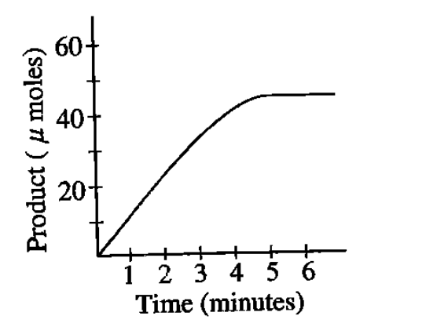

1. Based solely on the curve, what can be said concerning the calculated reaction rates at 1 minute and at 2 minutes?
2. The rate after 2 minutes is greater than the rate after 1 minute.
3. The rates are the same at 1 minute and at 2 minutes.
4. The rates are affected by high concentrations of inhibitors.
5. The rates are both zero.
6. The greater the rate, the faster the enzyme is denatured.
7. The rate of the reaction could also be determined by
8. measuring the change in the amount of enzyme
9. measuring the change in the amount of substrate
10. measuring the change in salt concentration
11. adding more substrate
12. adding more enzyme
13. What is the most likely explanation for the change in the slope of the line between 3 and 5 minutes?
14. The enzyme had denatured
15. The enzyme had achieved its maximum velocity.
16. A large amount of the substrate had been consumed.
17. An allosteric inhibitor appeared.
18. There was a dramatic change in the pH.

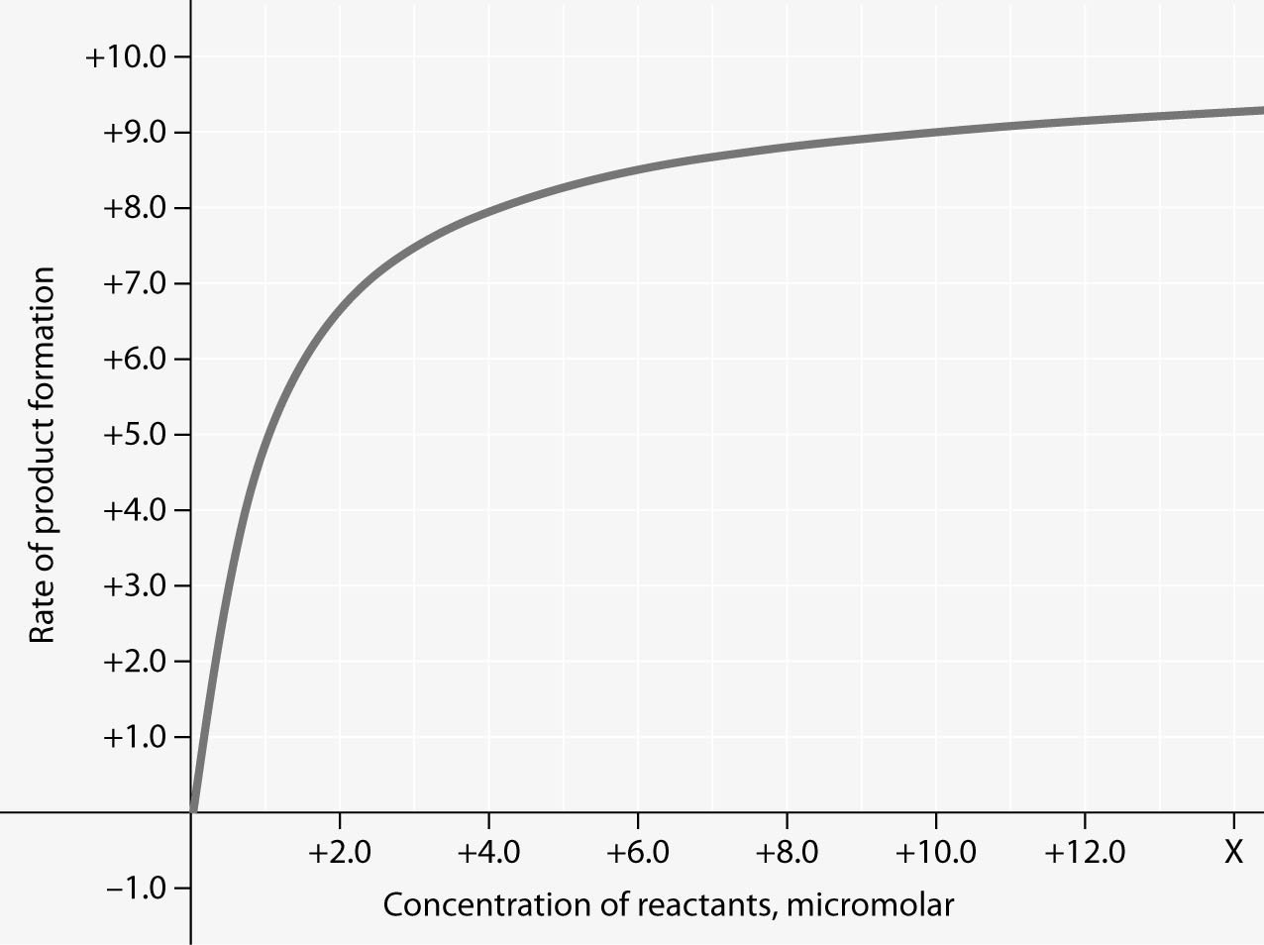

**Figure 8- Rate of an enzyme-catalyzed reaction as a function of varying**

**reactant concentration, with the concentration of enzyme constant.**

1. For the enzyme-catalyzed reaction shown in the figure 8, which of these treatments will cause the greatest increase in the rate of the reaction, if the initial reactant concentration is 1.0 micromolar?
2. doubling the activation energy needed
3. cooling the reaction by 10°C
4. doubling the concentration of the reactants to 2.0 micromolar
5. doubling the enzyme concentration
6. increasing the concentration of reactants to 10.0 micromolar, while reducing the concentration of enzyme by ½
7. Which of the following is a correct statement about the relationship between pH and the hydrogen-ion concentration of a solution?
8. There are no hydrogen ions present in a solution with a basic pH.
9. There are no hydrogen ions present in a solution with a neutral pH of 7.0.
10. The concentration of hydrogen ions in a solution with a pH of 7.0 is 100 times as great as that in a solution with a pH of 9.0.
11. The concentration of hydrogen ions in a solution with a pH of 5.0 is twice that in a solution with a pH of 3.0.
12. The concentration of hydrogen ions in a solution with a pH of 4.0 is 4000 times as great as that in a solution with a pH of 1.0.
13. Why does ice float in liquid water?
14. The liquid water molecules have more energy and can push up the ice.
15. The ionic bonds between the molecules in ice prevent the ice from sinking.
16. Ice always has air bubbles that keep it afloat.
17. Hydrogen bonds keep the molecules of ice farther apart than in liquid water.
18. The crystalline lattice of ice causes it to be denser than liquid water.

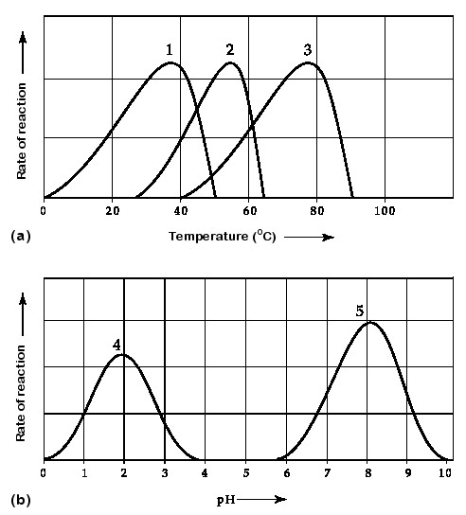

**Figure 9- Activity of various enzymes at**

**various temperatures (a) and at various pH (b).**

1. Which curve(s) on the graphs in figure 9 may represent the temperature and pH profiles of an enzyme taken from a bacterium that lives in a mildly alkaline (basic) hot springs at temperatures of 70°C or higher?
2. curves 1 and 5
3. curves 2 and 4
4. curves 2 and 5
5. curves 3 and 4
6. curves 3 and 5
7. Sickle-cell anemia results from a point mutation in the *HBB* gene. The mutation results in

the replacement of an amino acid that has a hydrophilic R-group with an amino acid that has a hydrophobic R-group on the exterior of the hemoglobin protein. Such a mutation would most likely result in altered

* + 1. protein tertiary structure and properties of the whole molecule as a result of abnormal interactions between R-groups and between adjacent hemoglobin molecules
    2. DNA structure as a result of abnormal hydrogen bonding between nitrogenous bases
    3. Fatty acid structure as a result of changes in ionic interactions between adjacent fatty acid chains
    4. Protein secondary structure as a result of abnormal hydrophobic interactions between R-groups in the backbone of the protein

**Questions 31 – 33 refer to the diagrams of organic molecules below.**

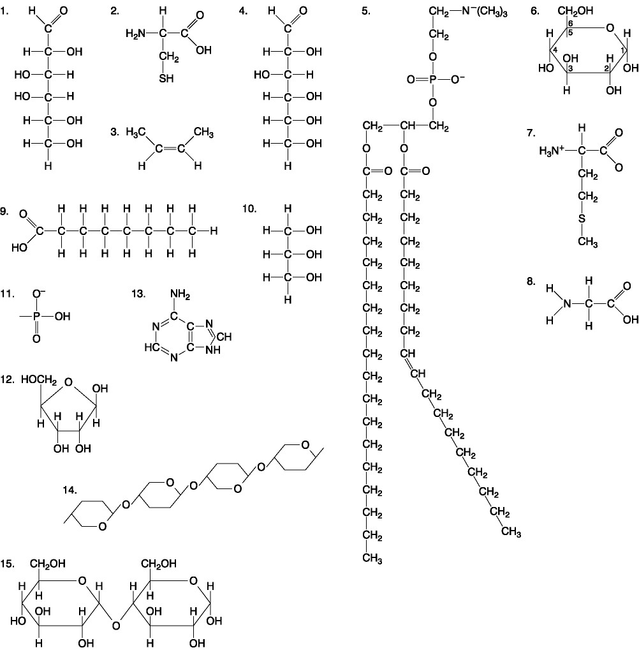

1. Which of the following molecules contain(s) an aldehyde type of carbonyl functional group?
2. 1 (B) 4 (C) 8 (D) 10 (E) 1 and 4
3. Which molecule has both hydrophilic “head” and hydrophobic “tail” properties?
4. 1 (B) 5 (C) 7 (D) 9 (E) 14
5. Which of the following molecules contain β glycosidic bonds?
   1. 6 (B) 9 (C) 14 (D) 15 (E) 6 and 15
6. This molecule could result from the hydrolysis of a protein.
7. 1, 4, and 6
8. 2, 7, and 8
9. 7, 8, and 13
10. 11, 12, and 13
11. 12, 13, and 15

**Questions 35 – 37 refer to the following diagram.**

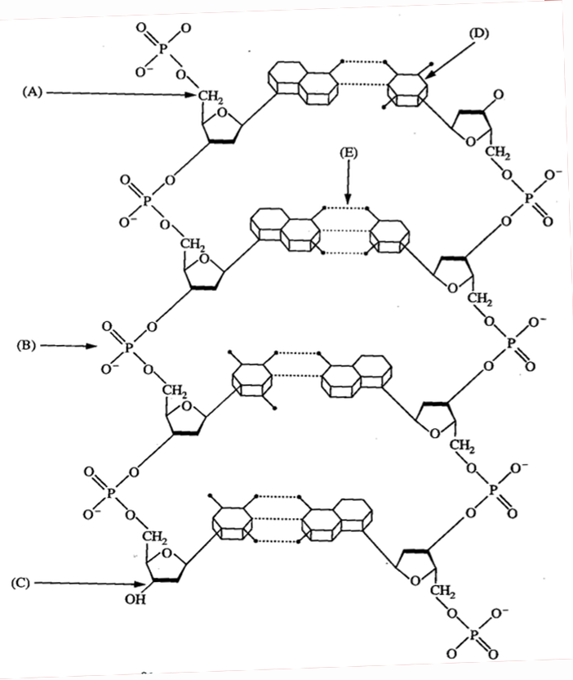

(AE)

1. A hydrogen bond.
2. A pyrimidine.
3. A 5’ carbon of deoxyribose.
4. How will brief heating (to 95°C) affect macromolecular structures in aqueous solution?
5. DNA double strands will unwind and separate.
6. Proteins will unfold (denature).
7. Starch will hydrolyze into monomeric sugars.
8. Proteins will hydrolyze into amino acids.
9. DNA double strands will unwind and separate, and proteins will unfold (denature).
10. What maintains the secondary structure of a protein?
11. peptide bonds
12. hydrogen bonds between the amino group of one peptide bond and the carboxyl group of another peptide bond
13. disulfide bonds
14. hydrophobic interactions
15. hydrogen bonds between the R groups
16. A chemist wishes to make an organic molecule less acidic. Which of the following functional groups should be added to the molecule in order to do so?
17. carboxyl
18. sulfhydryl
19. hydroxyl
20. amino
21. phosphate **TURN OVER🡪**

**Questions 41 – 43 refer to the following graph and information.**

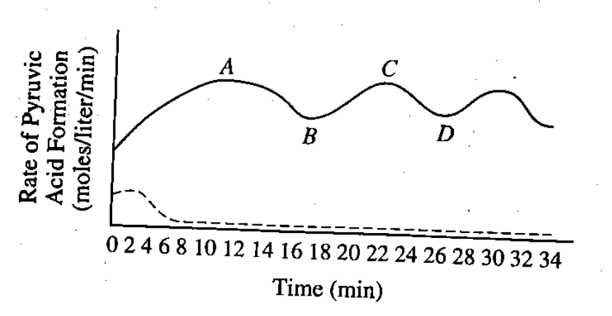``

A tissue culture of vertebrate muscle was provided with a constant excess supply of glucose

under anaerobic conditions starting at time zero and the amounts of pyruvic acid and ATP

produced were measured. The solid line in the graph above represents the pyruvic acid

produced in moles per liter per minute. ATP levels were also found to be highest at points A

and C, lowest at B and D. A second culture was set up under the same conditions, except that

substance X was added, and the results are indicated by the dotted line.

1. The rate of pyruvic acid formation fluctuates because
2. all glucose has reacted
3. all enzymes have been used up
4. the reaction is accelerated by positive feedback
5. the reaction is affected by negative feedback
6. coenzymes have begun to function
7. Which of the following best accounts for the shape of the solid line between points A and D?
8. After ten minutes the cellular enzymes became ineffective.
9. Respiration became uncontrolled.
10. ATP acted as an allosteric inhibitor on one or more of the enzymes.
11. The measurements of pyruvic acid were unreliable.
12. The cells required more glucose than was being provided.
13. It is most reasonable to hypothesize that, in the breakdown of glucose, substance X is
14. an activator
15. an inhibitor
16. a substrate
17. a coenzyme
18. a cofactor

**NAME: _____________________________________________**

**Grid In Problems: Part B consists of 2 questions requiring numerical answers. Calculate the correct answer for each question and bubble in the answer on the grid in portion of the exam.**

*Please complete the Grid In Questions directly on the test and enter your answer into the Grid In Answer Box.*

**Grid In Question 44-45- Use the image below.**

1. The enzyme phosphofructokinase (PFK) is an allosterically regulated enzyme that catalyzes the following reaction.

Fructose-6-phosphate + ATP🡪 Fructose-1,6-bisphosphate + ADP

The graph below shows that at certain concentrations ATP inhibits the enzyme, whereas AMP activates it. According to the information presented in the graph, when the concentration of fructose-6-phosphate is 0.5 mM, how many times more active is PFK in cells with 1 mM ATP + 0.1 mM AMP than in cells with 5 mM ATP? Express your answer to the nearest whole number.

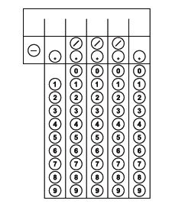****

1. Both myoglobin and hemoglobin are proteins that bind reversibly with molecular oxygen. The graph below shows the oxygen-binding saturation of each protein at different concentrations of oxygen.

At what partial pressure of oxygen does myoglobin’s binding to oxygen decrease and slow down while hemoglobin’s binding increases rapidly. Round to the nearest whole number.

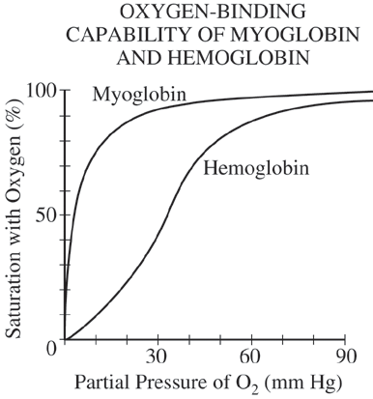

**MULTIPLE CHOICE BUBBLE SHEET**

Please notice that you must enter your **zip grade ID first** and **bubble number in**, then question 1 begins after the ID. Please put multiple choice answers on this zip grade bubble sheet.

